**PROJECT**

**Setup, Learning Switch and Control a Slice of Real Network**

**Introduction**

Information sharing and control for businesses both public and private entities has greatly been diversified and well simplified with the advancing technology. Use of *virtualized* oriented and *SDN protocol* supported networks has made these all possible in more simplified formats based on networks management and control.

**OpenFlow(OF)**

This is a protocol that is considered one of the initial pioneers of the ***software-defined networking (SDN)*** standards. It defines the protocol of communication in SDN architecture. This enables SDN-based controllers to directly interact with the network devices both physical and virtual such as switches, routers among other more devices on a network.[sdxcental, 2013]

The *SDN controller* relays information to network devices switches and routers ‘below’ and to applications and business logic ‘above’ hence operates as the logic and ‘brain’ of the SDN networks. For total compatibility and working on an OpenFlow (OF) environment, devices that intend to initiate communication with an SDN controller needs to support the OpenFlow(OF) protocol. Through a special provided interface, the changes made by the SDN controller are pushed down to switch/router flow-table for easier administrative management. Operation and performance control.[sdxcental, 2013]

The main significance of OpenFlow protocol in supporting SDN communication standards are tied on three main features in networking operations which includes;

* **Programmability**

This highly enables improved innovation in networking as well as accelerated introduction of new features and services.

* **Abstraction**

This greatly checks on improved decoupling of network primary components, software and hardware, configuration of physical and logical components.

* **Centralized intelligence**

This necessitates, simplified provisioning, improved policy management and optimized

performance of the network.

**Objectives**

* OpenFlow protocol and its application in networking
* Network provisioning using OpenFlow and SDN architecture
* Mininet emulator application in network simulation
* Network controller and learning switch operation

**Mininet**

This is a network emulation platform that allows creation of virtual OpenFlow networks, controllers, switches, hosts, links and other network properties on a single virtual or real machine. It forms a fundamental tool in *development*, *teaching* and *research.*

It allows developing networks in Software-Defined Networking (SDN) environment using OpenFlow protocol.[Mininet, 2021]

To get the tool installed in our environment of operation either real or virtualized machine we use the following command instructions:

**git clone git://github.com/mininet/mininet**

This pulls the installation files from a native github source.

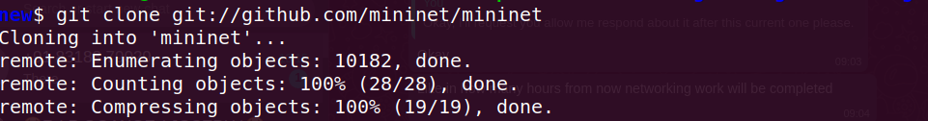Figure 1: Clone mininet repository from github

Then from this we run the tool installation after the whole cloning process has been executed. We enter into the imported mininet directory labeled *mininet* and into the utility folder labeled *util* and execute the following command instruction in terminal environment with root user privileges

**sudo ./install.sh -a**

This installs all the features of mininet tool in to the host machine.

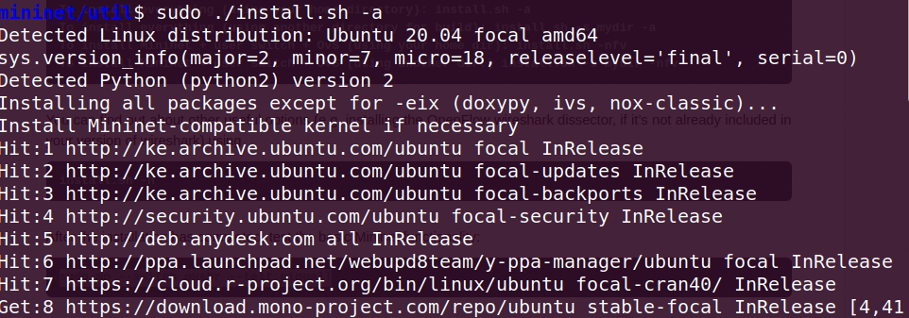Figure 2: Mininet installation

This will take some time depending on the network speed. However, upon successful completion we’re supposed to have all the essential components favorable to support mininet tool in network operations and simulation.

After successful installation we can run the test for the tool using the command:

**sudo mn --switch ovsbr --test pingall**

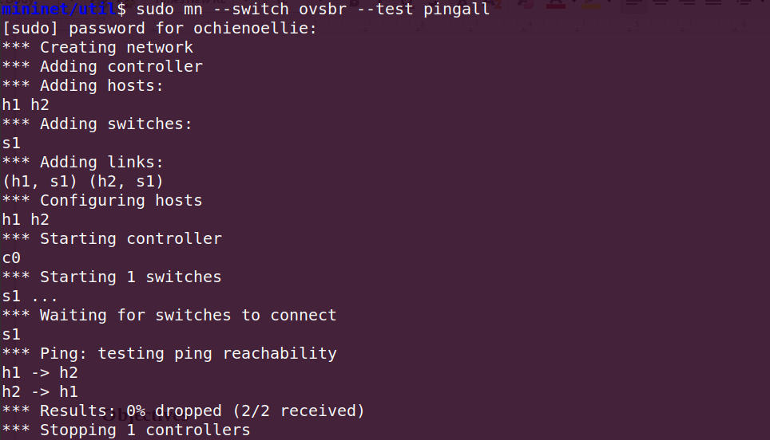Figure 3: Mininet tool testing

Hence from here we launch the mininet tool operating console using the command

**sudo mn --topo single,3 --mac –switch**

**ovsk --controller remote**

This results in the creation of a new virtual machine VM with the following parameters

* 3 virtual hosts each with separate IP address
* Single OpenFlow software switch
* Connected each virtual host to the switch
* Set MAC address of each virtual host to its IP
* Configure the OpenFlow switch

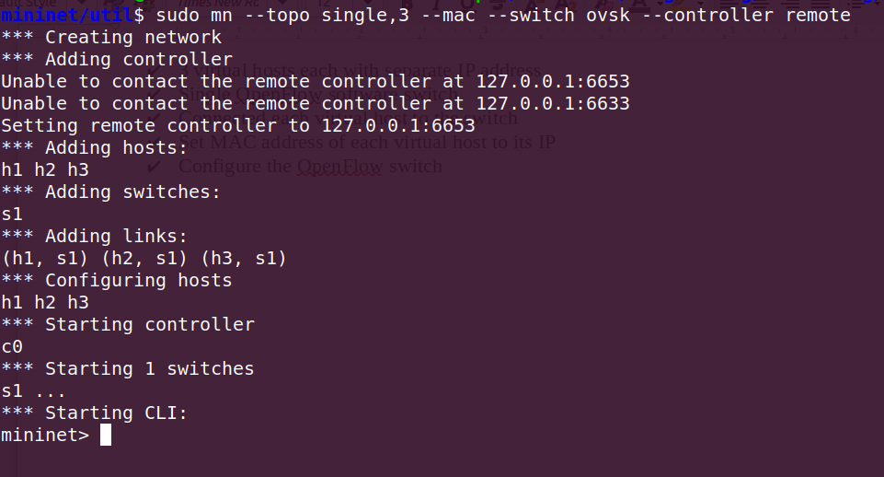Figure 4: Mininet setting up VM

**Create a Learning Switch**

Here we will use a controller platform of python based language POX.

Install it from git repository using the command

**$ git clone http://github.com/noxrepo/pox**

and after this we can run the test hub sample using the command

**$./pox.py log.level --DEBUG misc.of_tutorial**

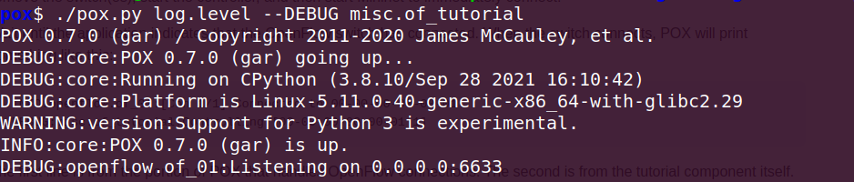Figure 5: Running POX basic hub

To verify controller reachability we perform

**mininet> pingall**

This proves sanity check for connectivity

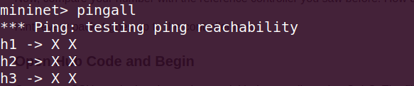Figure 6: Mininet controller reachability check

**References**

**sdxcental, 2013**  - What is OpenFlow and How is it Related to SDN?

Retrieved: December 3rd 2021

https://www.sdxcentral.com/networking/sdn/definitions/what-is-openflow/

**Mininet, 2021 -** An Instant Virtual Network on your Laptop (or other PC)

Retrieved: December 3rd 2021

http://mininet.org/